Grading Papers in Blackboard Part 1
(Please note: All of these instructions are available in the Online Instructional Resources site on Blackboard. Go to Course Content > Lessons Folders from Blackboard Training > Lesson 6: Creating Assignments > Grading Assignments.

How do I grade an assignment in the Grade Center?

- From the "Course Management" menu, click the drop-down box next to "Grade Center" and select "Full Grade Center."
- Use the scrollbar along the bottom of the student list to scroll over and find the name of the assignment.
- Once you find the name of the assignment, locate a student with a yellow exclamation point. This signifies that s/he has submitted an assignment.
- Mouse over the cell and click the double down arrow to view the submission.
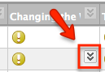
- Select the “Attempt” from the drop-down list.
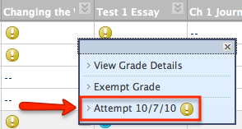
- The screen that displays will show the assignment submission history, attempts, and instructor notes.
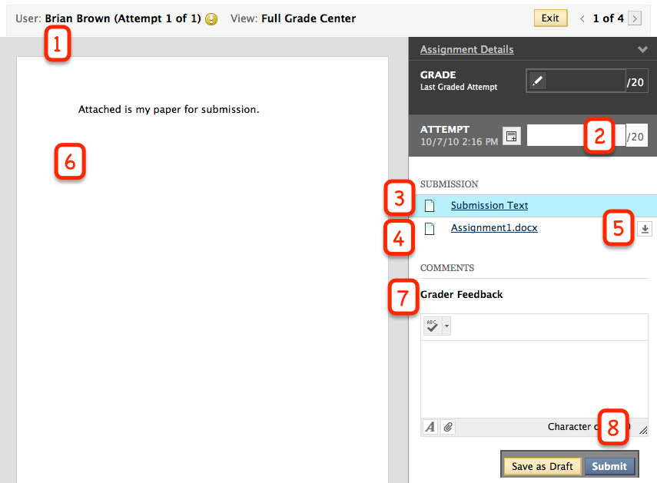

Key for image above:

- Student name you are currently grading
- Enter the points s/he earned
- Text the student may have typed in the “Type Submission” box
- Any files the student attached to the assignment will display as an entry. You can click on them (if they are Microsoft Word, Excel or PowerPoint files) and view them directly in Blackboard.
- Button to download any attached files
- The viewing space for the student’s attached assignment.
- Textbox where you can type feedback to the students (they will see it in MyGrades)
- Submit button to submit their score and any feedback you’ve provided

- To view what the student has submitted, look under the "Submission" area. You can see the files or text they have submitted. Clicking on these files will provide you with a view of them in the preview area. If they are not Microsoft Word, Excel, or PowerPoint files, you will have an option to download the document.
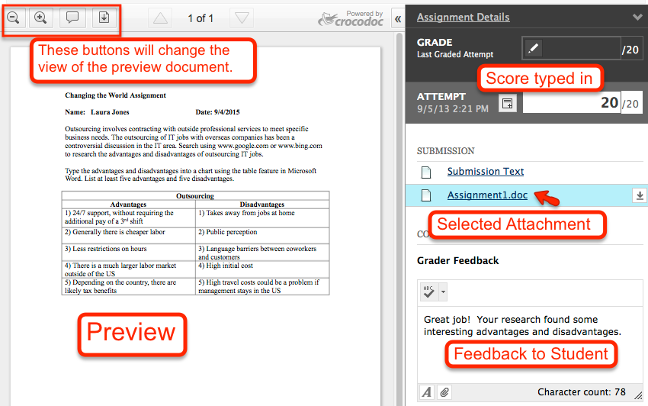
- Enter a "Grade" and "Feedback" to the student.
- When you are finished grading, press "Save as Draft" to save your comments and score, but not make them visible to the student or added into their total points. Click "Submit" to update the grade and make your comments visible to the students.
- Clicking "Submit" will take you to the next student who needs grading.
- To return to the Grade Center, click "Exit" at the top of the screen.

Please see the Grading Assignments Part 2 for the features on how to “mark up” a student’s paper to give them feedback.

